AP-Inventory Report Guide

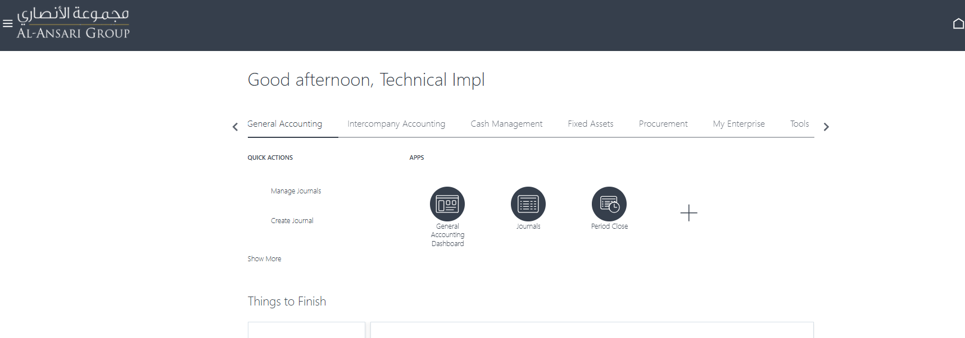

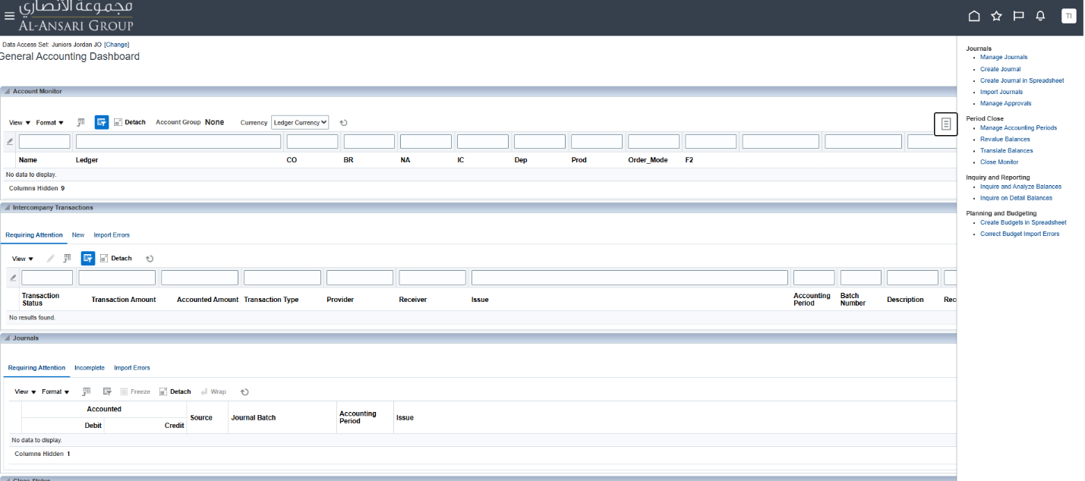

Natural Account: 230070102
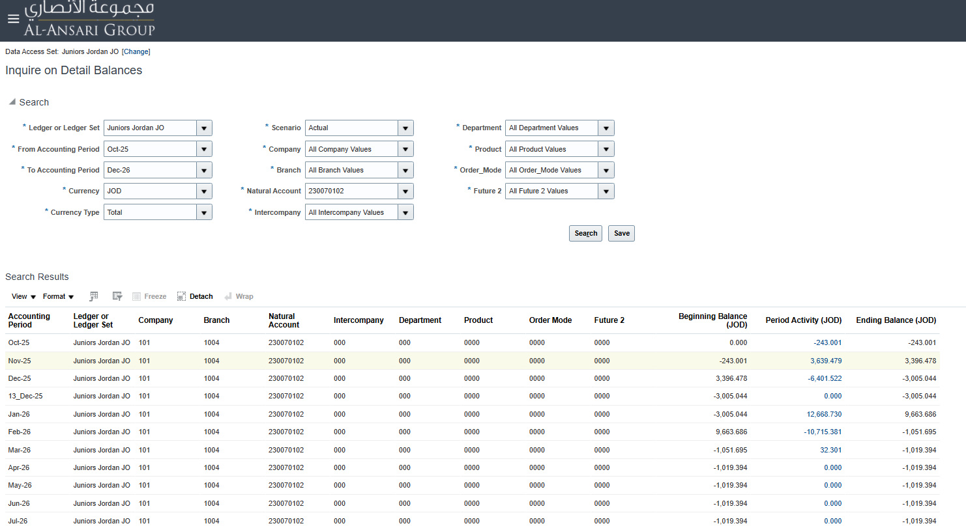

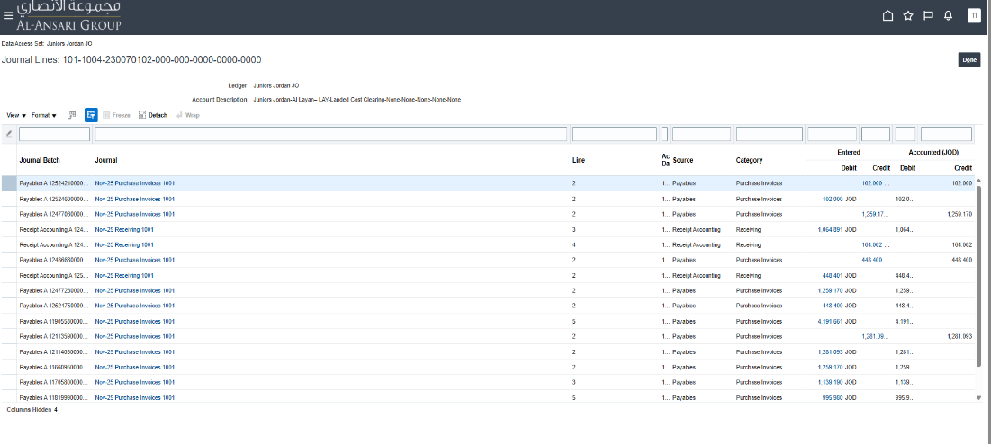
Account Combination, Ledger Name, Account Description:
(click on the journal name)

GL Sequence:
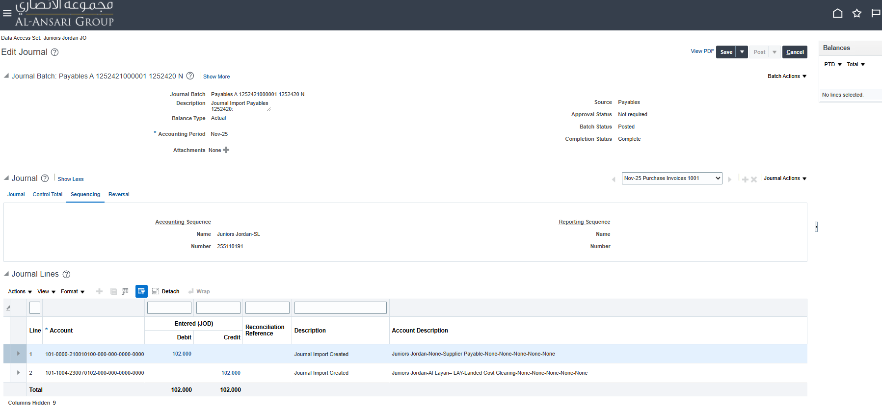

After you click cancel, click on the blue debit or credit amount:
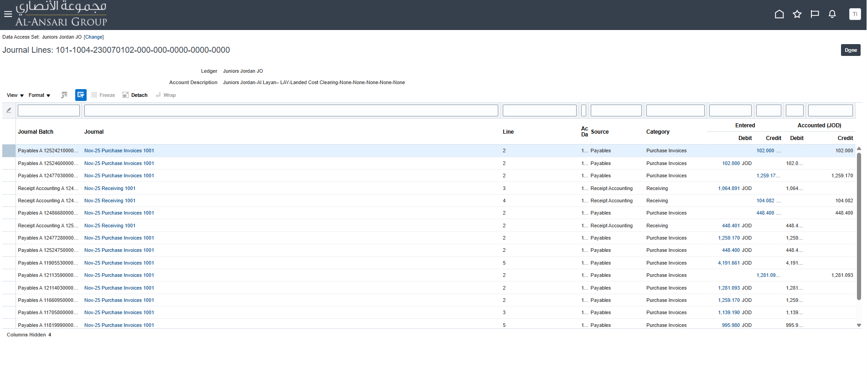

Accounting Date, Accounting Class, Credit or debit, Event Type:
then click on View Journal Entry:
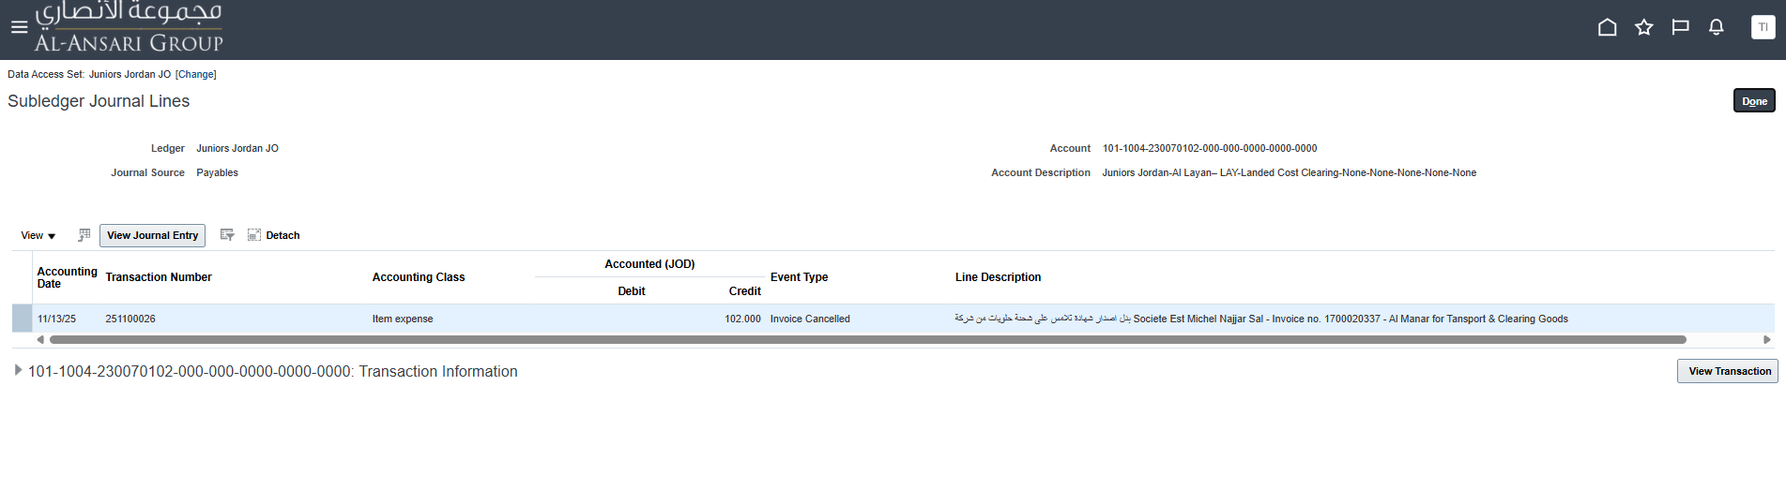

Supplier Number, Invoice Num:
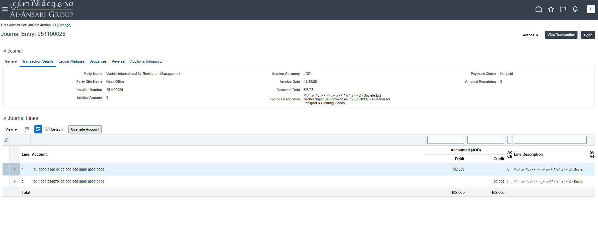
Then click on Ledger Attributes

Period Name, Transfer to GL Status:
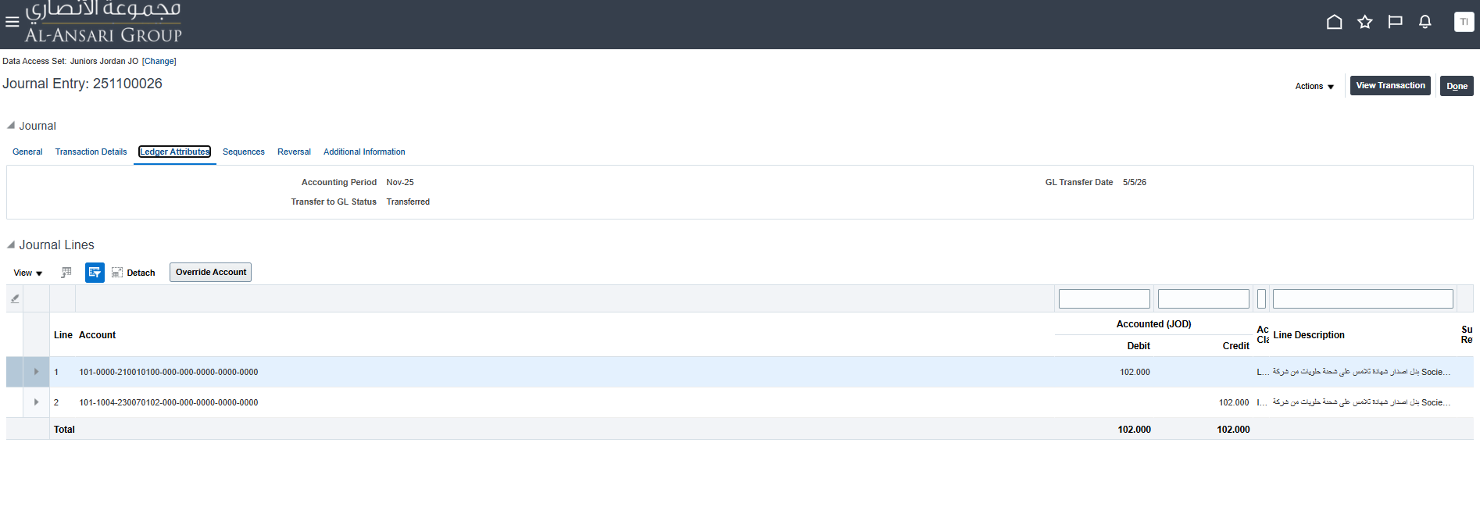
Then click on Sequences:

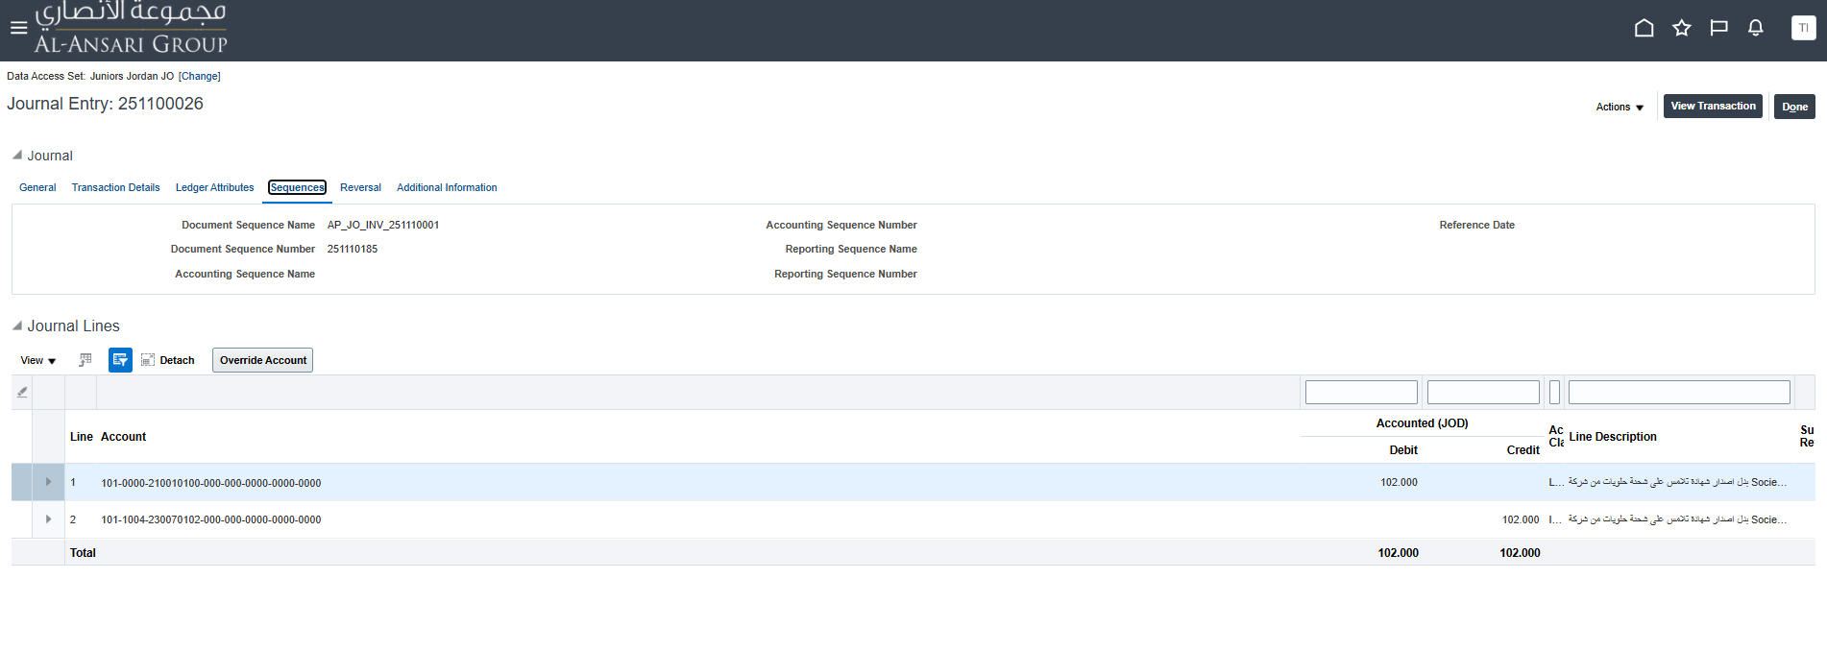
Voucher Number:

Example when the source is Receiving, click on the blue amount
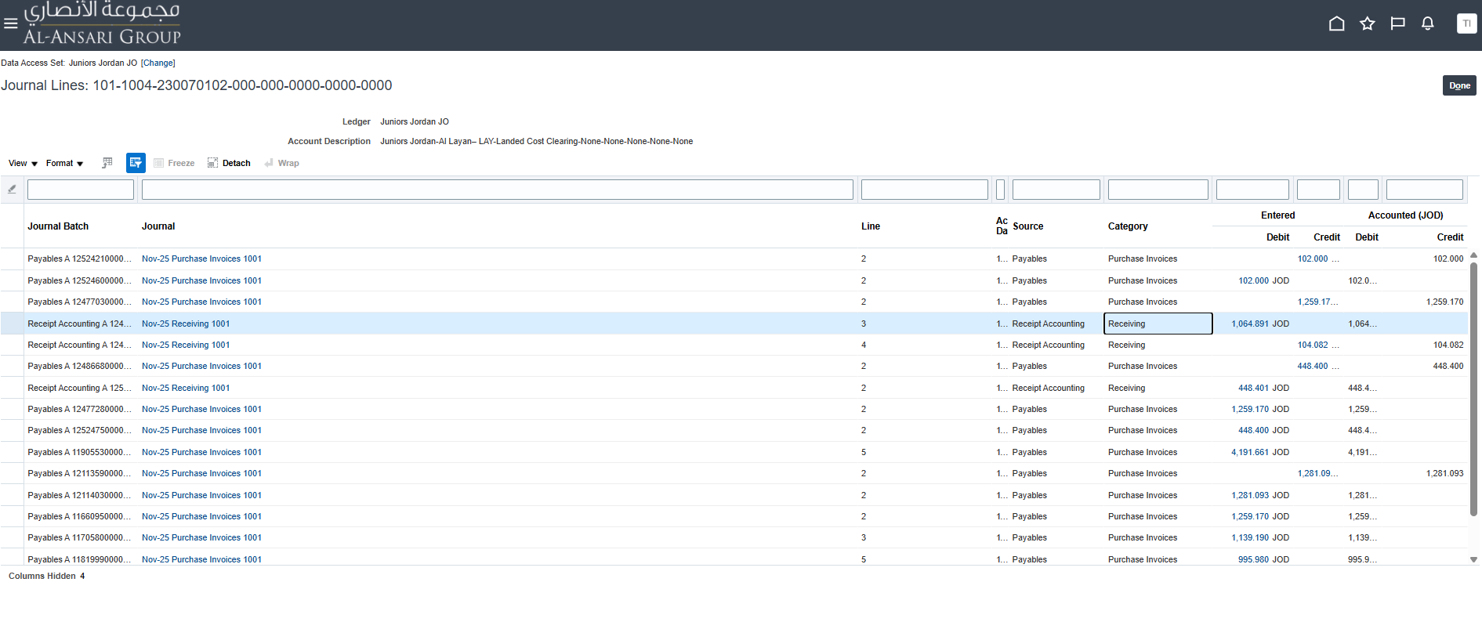

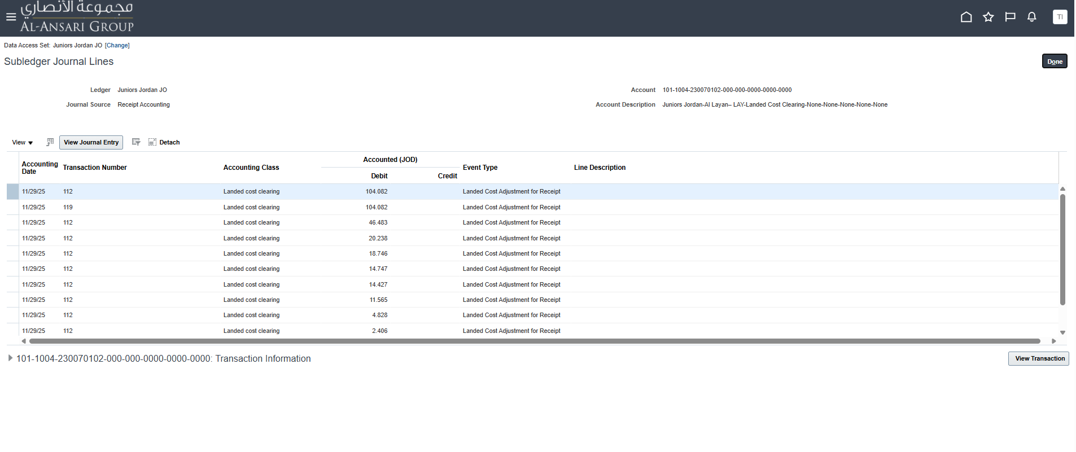

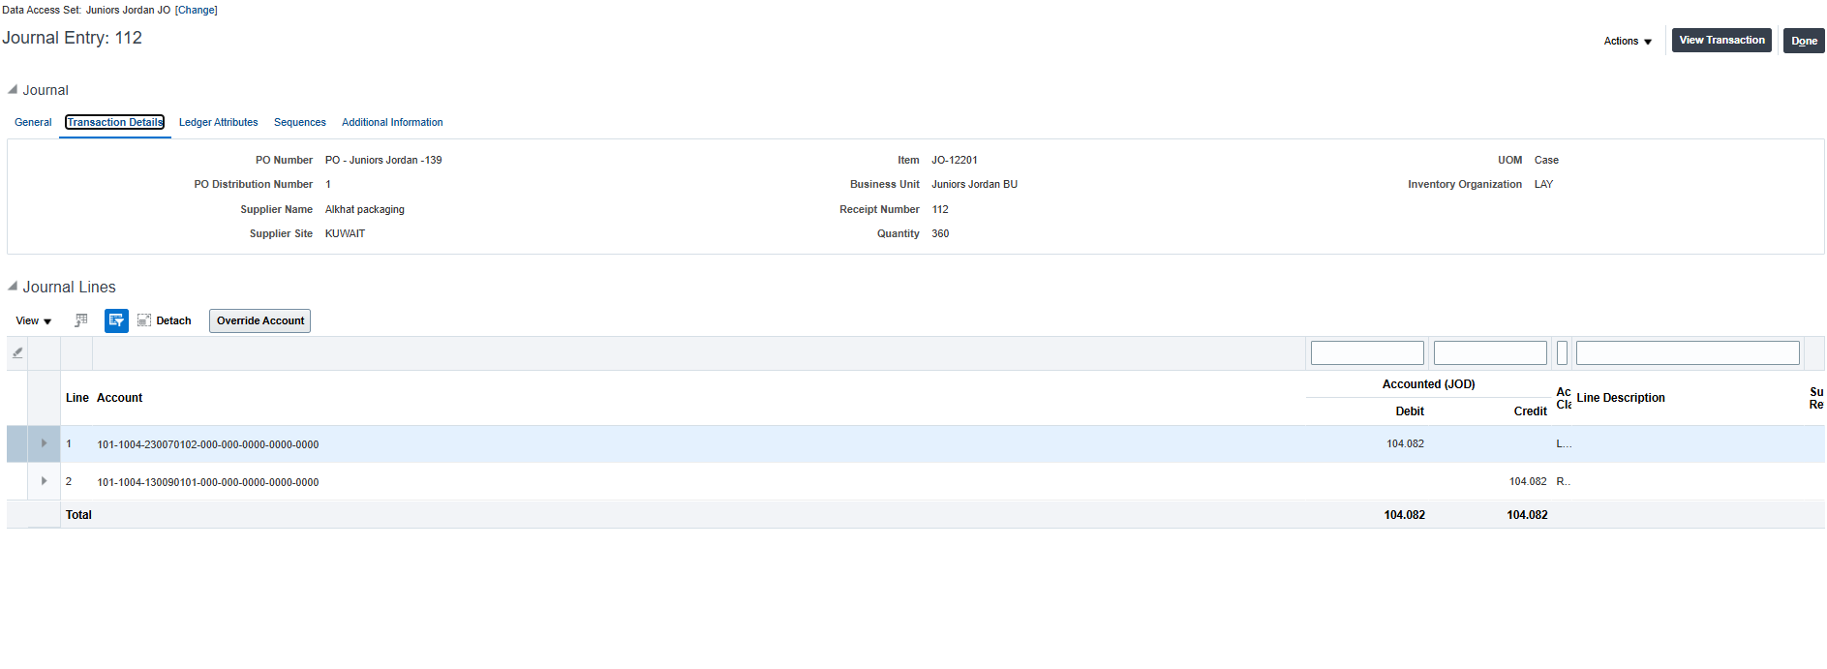

PO Number, Item, Receipt Number:

